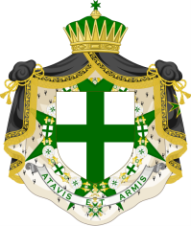

Commandery of London and Westminster

AGM and Commandery Away Day
Queens’ College, Cambridge, CB3 9ET

Saturday, 22nd September 2018

BOOKING FORM

Where possible, please email the Secretary, Kit Burdin on secretary.london.lazarus@gmail.com to make your booking, including your name and those of your guest(s).

The form can also be sent, by those who wish to book by post or pay by cheque, to the Secretary, c/o 2 St George’s Buildings, St George’s Road, London, SE1 6EP.

Name: ……………………………………………………………………...………………………………..

I would like to reserve ………….……. place(s) on the St Lazarus trip to Cambridge on
Saturday 22nd September.

Names of guests: ………………………………………………..…………………………………………

…………………………………………………………………………………………….…………………

……………………………………………………………………………………….………………………

I have made payment for £……………….. (£37.50 per person) by:

Bank Transfer, giving the reference “Cambridge”, to our account with HSBC called “Commandery of London and Westminster” – Account number: 22133717; sort code: 40-06-29

or

Cheque (made payable to “Commandery of London and Westminster”)

